Robert Pearson

Dr. Sarkar

CS 150

December 11, 2023

Final Project: Who Wants to Be a Millionaire?

The goal of this project was to create a fun and interactive game for anyone to play. I used python to create game based off the TV game show, “Who Wants to Be a Millionaire?”. The user gets brought through a series of 15 questions where they will need to answer all 15 correct to win the million-dollar prize.

The development process started off with finding a question bank that I could use in my project. Once I had found a question bank, I was able to start the code with the plan on including features such as ‘How to Play’ , ‘Start the Game’, and ‘Stats’. With this in mind I was able to start the main class and establish my functions. My first function would be “how_to_play”. It provides the user with detailed instructions on how to play the game and how to correctly enter each answer. The next function would be “questions” and when this is called it starts the game. This function started off with a while loop that continued through the loop if the user got the question correctly. It was also call upon question bank, which was accessed through a JSON file, and randomly select a question from it. It would display the question-and-answer choices, then gives the user the chance to enter the correct answer. If they correctly answer, the amount of money they could win goes up but if they answer incorrectly, the loop breaks. The next function would be “win” and it would display how much the user won based off numerous conditions. If the user decided to quit halfway through, they would win a set amount of money based off how many questions they answer correctly. It also would display if the user won nothing or that if they got more than 5 or 10 questions correct but missed one, it would display that amount of cash.

One of the main challenges I encountered was how to access a JSON file. The question bank that I found used a JSON file type and we didn’t learn how to access them in class. I ended up resolving this dilemma by researching how to access it learning that you had to import JSON and open the file that way. Another challenge I was faced was issues with variables not being accessed correctly. I was able to fix this by using global variables through my project. From the challenges I faced, I was able to learn about accessing JSON files in python and gain a better understanding of how local and global variables worked throughout.

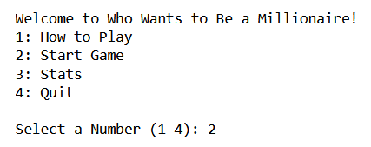 My project started with an easy to navigate menu that gave the user a few options to either learn how to play, play the game, see their stats, or quit. The user would input a number and based on that number the code would call one of the functions from the main class. If the user selected to start the game, they would be given the option to either 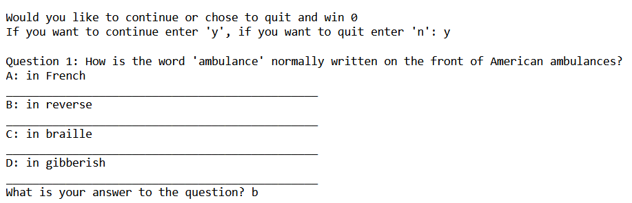

continue or quit. If they chose to continue it would ask them their first question. It would continue through this process until they either missed a question or got all 15 correct.

After completing the project, there was a few things that I could’ve improved on or added to my code. One feature that could’ve been added was the ability for the user to get a hint on questions that were particularly hard. One feature that could’ve been improved on was if the user accidentally mistyped while answering a question. This would automatically count it as incorrect even if they knew the answer. While testing, I found myself encountering this problem quite a bit.

Through this project, I was able to gain a better understanding of how the random module worked, the differences between global and local variables, and how to open JSON files within python. I was able to create a fun and interactive game that tested the user knowledge.

Works Cited

“Read JSON File Using Python.” *GeeksforGeeks*, GeeksforGeeks, 27 July 2023, www.geeksforgeeks.org/read-json-file-using-python/.

“Who Wants to Be a Millionaire?” *Wikipedia*, Wikimedia Foundation, 1 Dec. 2023, en.wikipedia.org/wiki/Who_Wants_to_Be_a_Millionaire%3F.

“WWTBAM JSON File.” *Pastebin*, pastebin.com/QRGzxxEy. Accessed 11 Dec. 2023.